GUIDELINES ON EXCISE DUTY REFUND FOR DIPLOMATIC AND CONSULAR REPRESENTATIVE OFFICES AND INTERNATIONAL ORGANISATIONS

- Purpose of the document

The purpose of these guidelines is to explain the process of application for refund of paid excise duty for diplomatic and consular missions and international organizations and their staff, for excise goods purchased in the excise territory of the Republic of North Macedonia.
The registered entities in the system, first need to submit an application for approval in the CDEPS - Trader Portal. After the application has been approved they will later be able to submit declarations of excise duty refund.

- Access to the Trader Portal – excise duty application

The system can be accesses on the following link „https://trader.customs.gov.mk/myAccount-ui/protected/welcome.htm“ or via the Customs Administration’s website www.customs.gov.mk, by clicking on the tab e-customs, СОЦДАД (CDEPS), Стартувај (Start) (Image 1).

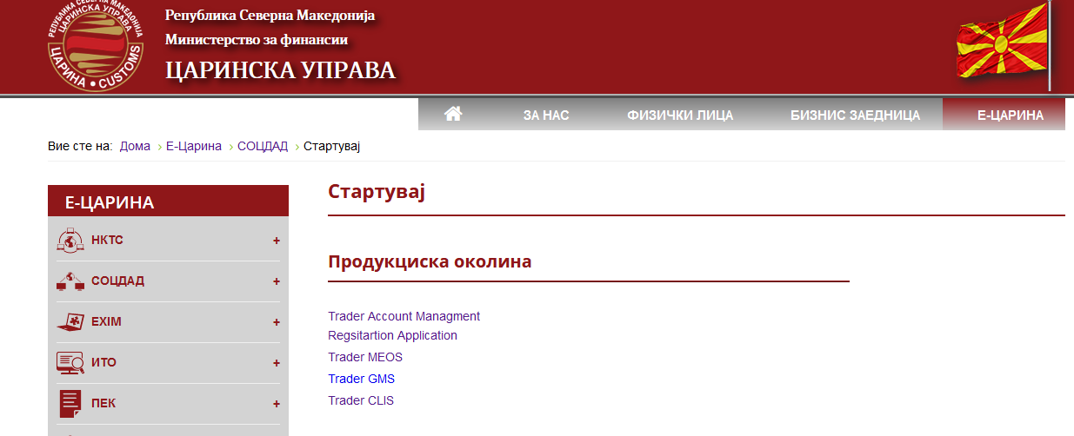
Image 1

To register a user in the system, click on “Registration Application”, for submission of applications for approvals/authorisations, click on the link to “Trader MEOS” and for submission of declarations for excise duty refund, click on the link “Trader Account Management” and then TDP - Trader declaration Processing.

Access to the Trader Portal – excise user application starts by logging in on the login tab (Figure 2). A simple screen appears with the CDEPS and Customs Administration logo with two fields to fill in: USER NAME and PASSWORD, and two additional fields: RESET and LOG IN.

2.1. Log in window

Logging in in the Trader Portal – excise application starts by filling in:

- USER NAME (example: name, surname of the user)
-PASSWORD (example: a minimum of 12 characters –letters, numbers и symbols)
- click LOG IN (If the inserted data are correct) or press the RESET button to delete the inserted data and re-enter username and password (if the inserted data is incorrect).

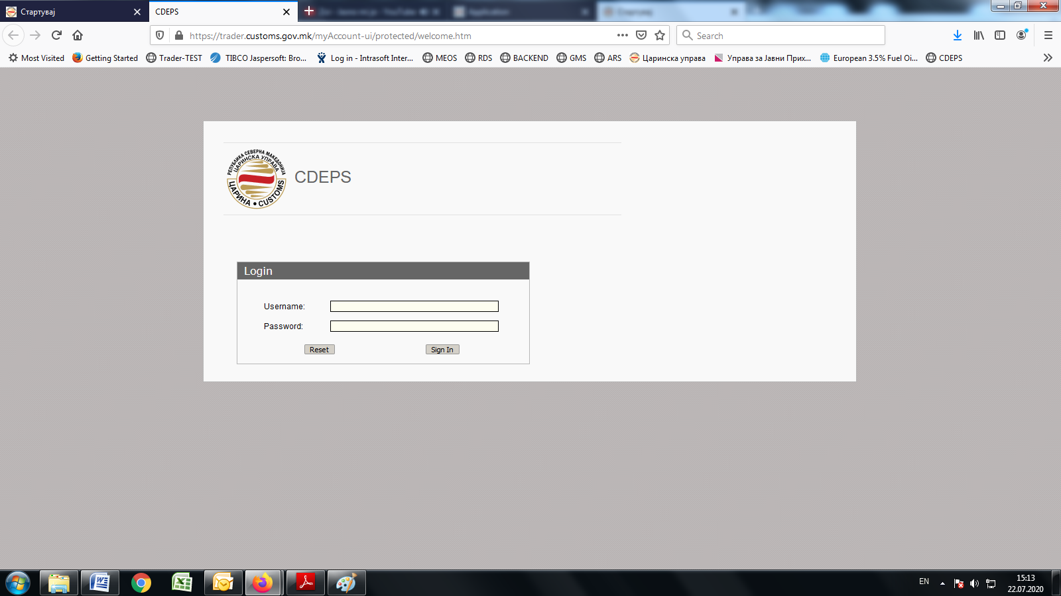
Image 2

3. Submission of application for granting authorization (approval) for excise duty refund
After successful log in on the link "Trader Account Management", the system displays the common TRADE PORTAL and select "MEOS - Management of economic operators system" (Image 3).

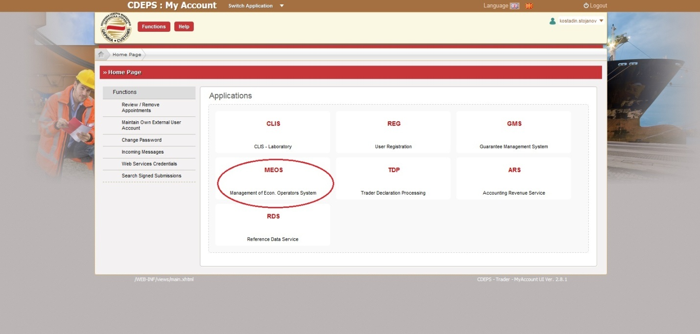
Image 3

If the individual is authorized in the CDEPS to represent a legal entity, by clicking the tab "MEOS - Management of economic operators system", the system provides an option to choose whether you wish to continue representing yourselves or you wish to continue representing a legal entity, in this case an embassy, consular mission or international organization (Figure 4).

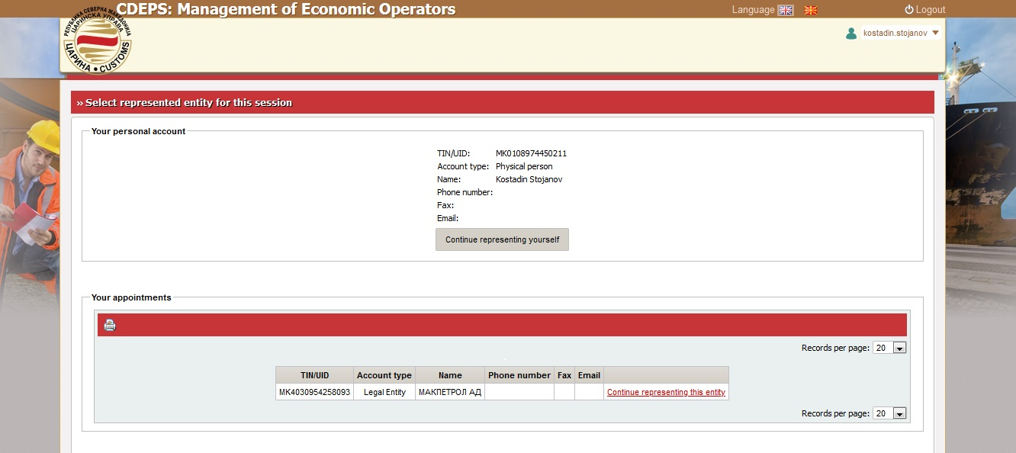
Image 4
If the applicant is authorized to represent an embassy, consular mission or international organization, and you wish to apply for excise duty refund for your own needs, select "Continue representing yourself".

If the applicant is not authorized to represent an official entity, by selecting "MEOS" a new window opens directly.
Clicking on the tab "Authorisation Managements" a menu pops up giving option to submit a new application for authorisation, submit an application for amendment of an issued authorisation, to search submitted applications and search issued authorisations (Figure 5).

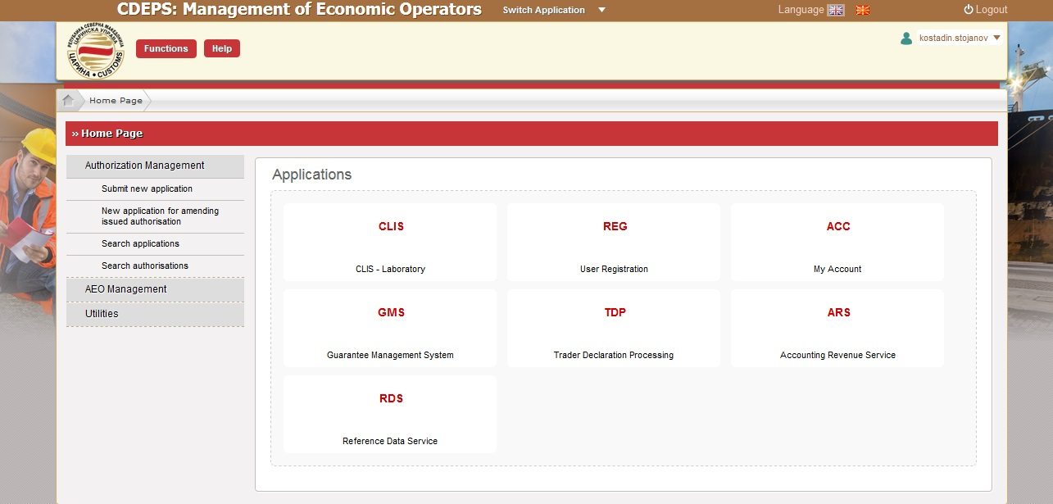
Figure 5

By selecting the tab "Submit New Application" a list appears showing all the authorisations that can be requested through the system. Select Excise Duties Refund from the list of Excise authorisations (Image 6).

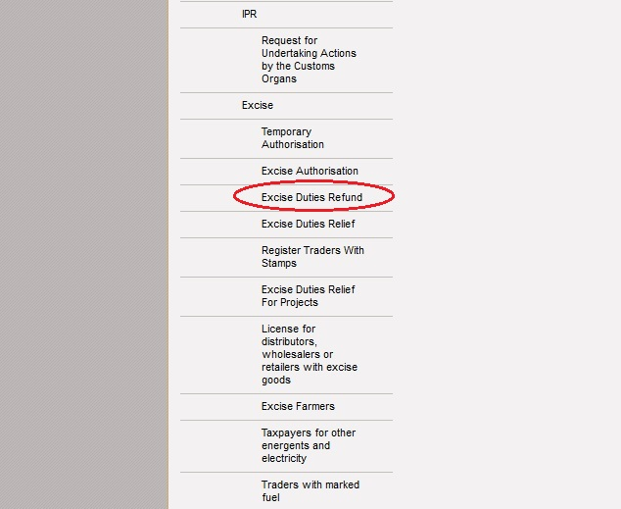
Image 6

When applying for an authorisation for an embassy, diplomatic or consular mission or international organization, select "Special subjects for official needs" from the drop-down menu (Figure 7). In case an individual submits an application for his/her personsl needs, select "Special subjects for private needs”. (Image 8).

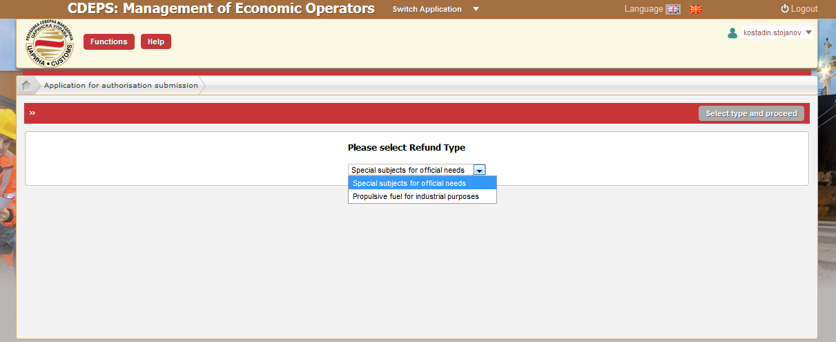
Image 7
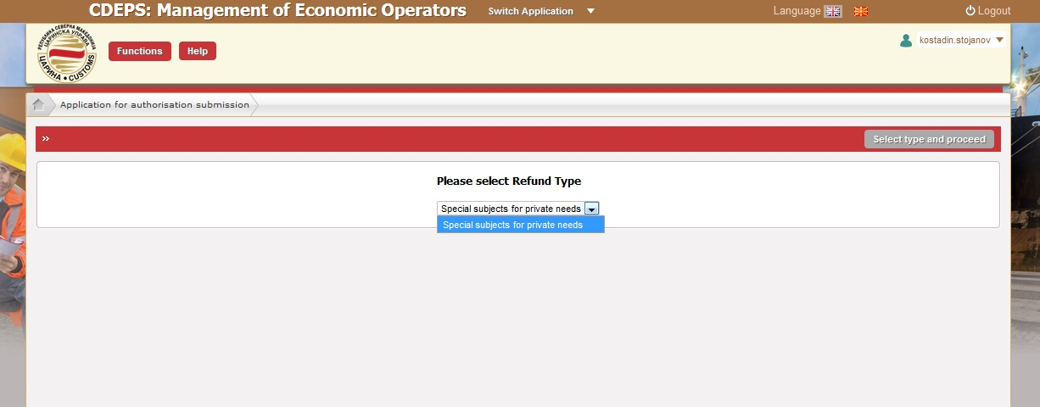
Image 8

After selecting the type of refund application, click on "Select refund type and continue" field at the top right side of the window. A new window pops up with a summary of the application, assigned a unique system reference number.

Continue filling in the data in the application. From the drop-down menus in the section "Issuing customs authority" and "Supervising customs office" select MK09000-Central Administration (Image 9).

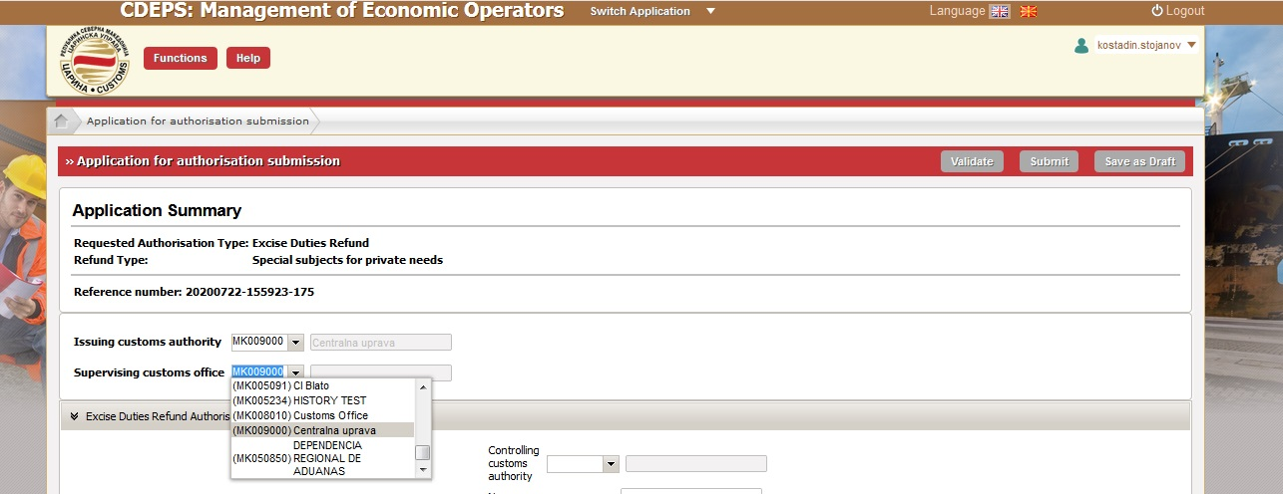
Image 9

In the general part of the request "Controlling customs authority", select MK09000-Central Administration from the drop-down menu, insert the name and surname of the person applying for excise duty refund. The ID number is filled in automatically (Image 10).

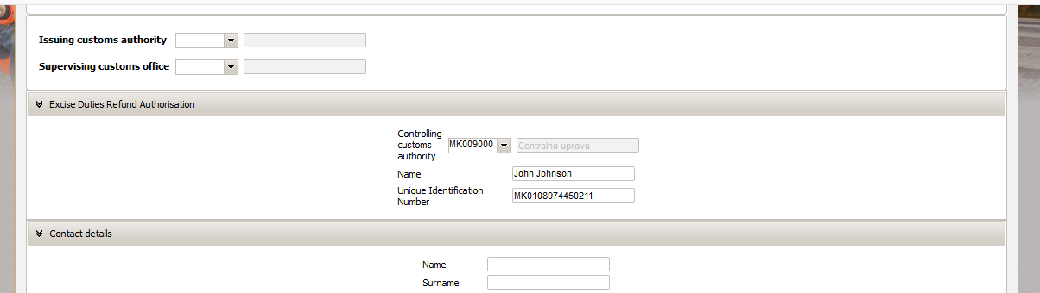
Image 10
Please fill in the contact information by entering all requested fields (image 11).

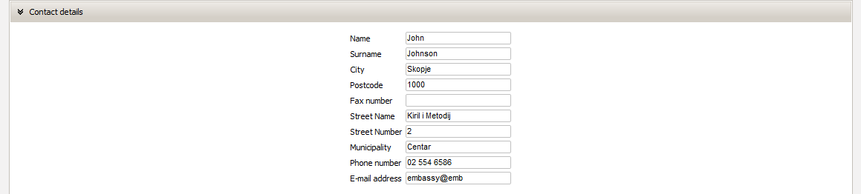
Image 11

In the “Special subject” part, select the code of the special subject form the drop-down menu, depending on whether it is an embassy, consulate or international organization. (Image 12).

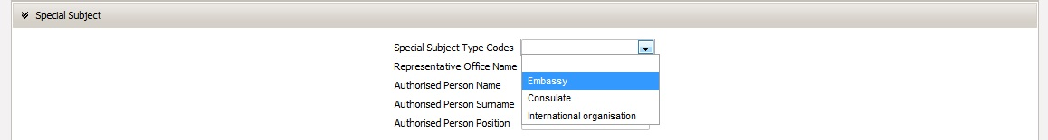
Image 12

The applicant completes the remaining data in the part "Special entity", i.e.: representative office name, authorized person name, authorized person surname and authorized person position (Image 13).

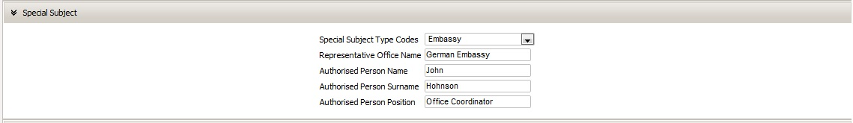
Image 13

The applicant completes the data in the part „Bank account“, i.e. Bank name, Transaction reference number, Bank account holder, Bank account number and Transaction account,
(image 14).

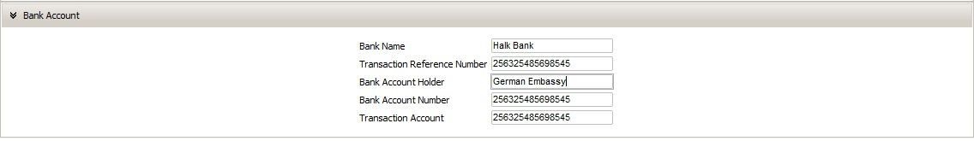
Image 14

Once the application is complete there are options to: Confirm application, Submit application and Save as a working document. (Validate, Submit and Save as Draft).
By selecting the option "Confirm application " the system checks whether the application is completely and correctly completed.

Upon submission, the application is processed on the Customs Administration’s portal where it is reviewed and can be approved, returned for completion or rejected. The decision process concerning the submitted application is two months. The applicant can monitor the status of the application in "MEOS" by clicking on field "Authorisation Management" and selecting "Search application". In the search criteria, under "Application type" select "Excise Duty Refund " and then Search (Image 15).

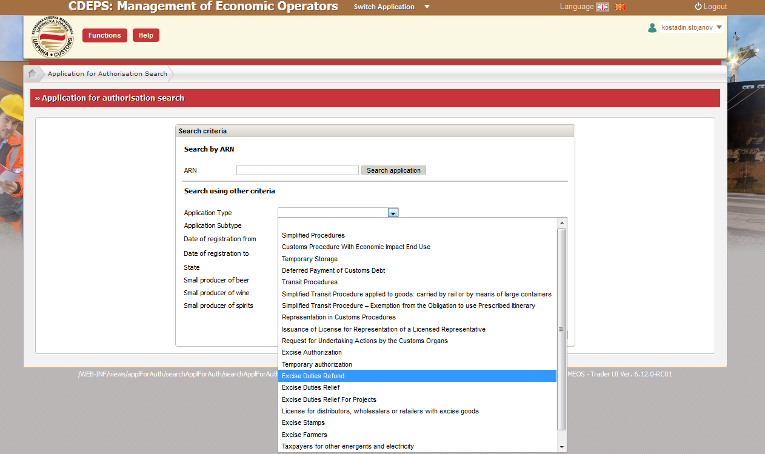
Image 15

The system generates the submitted excise duty refund applications, and in status you can monitor the status of our request. The example in Image 16 shows that the application has been approved.

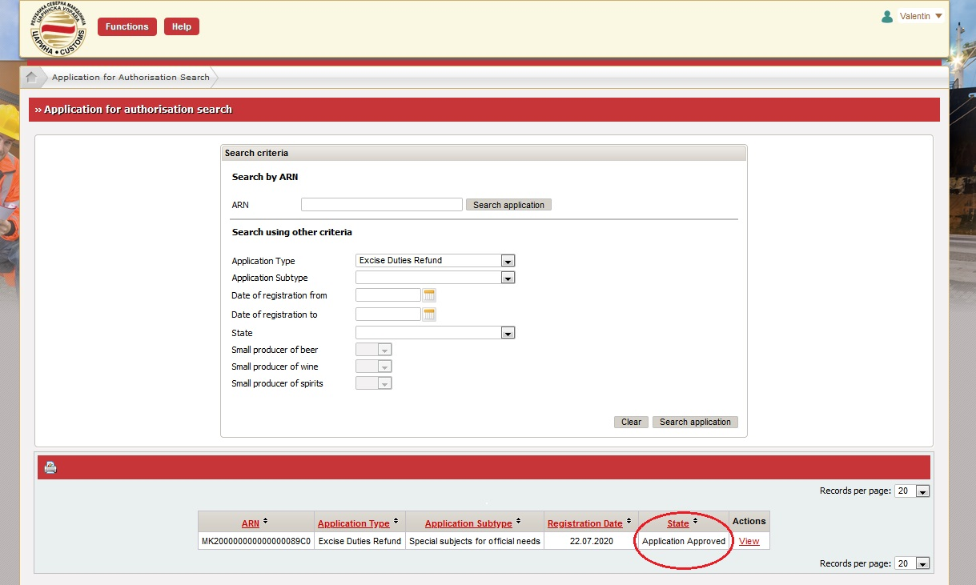
Image 16
Once the excise duty refund application has been approved by the Customs Administration, the applicant can start filing in excise duty refund declarations.

- Excise duty refund declarations

To submit excise duty refund applications select “Trader Account Management” then click on the TDP – Trader declaration Processing tab (image 17).
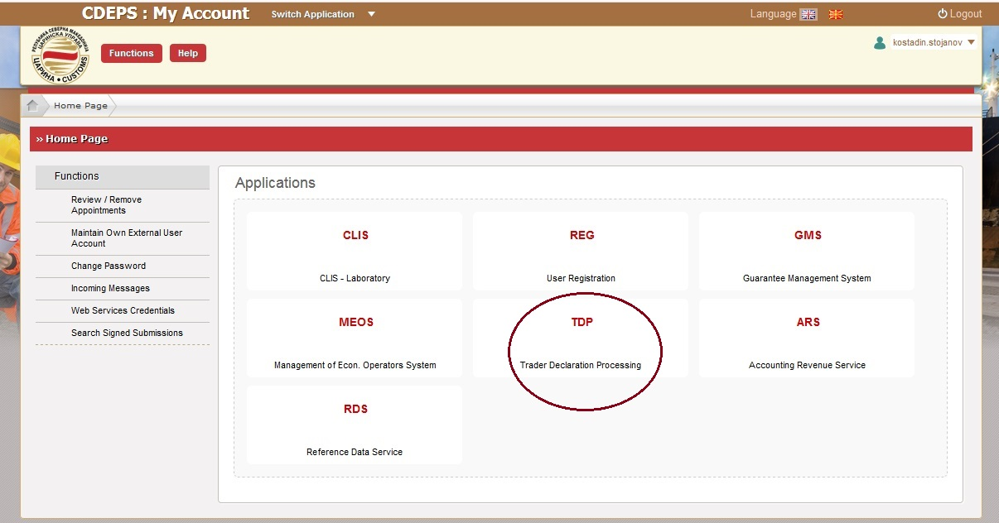
Image 17

By selecting “TDP” the system shows different menus of the Portal including: Actions, Transit, Import, Export, Excise and Help (image 18).
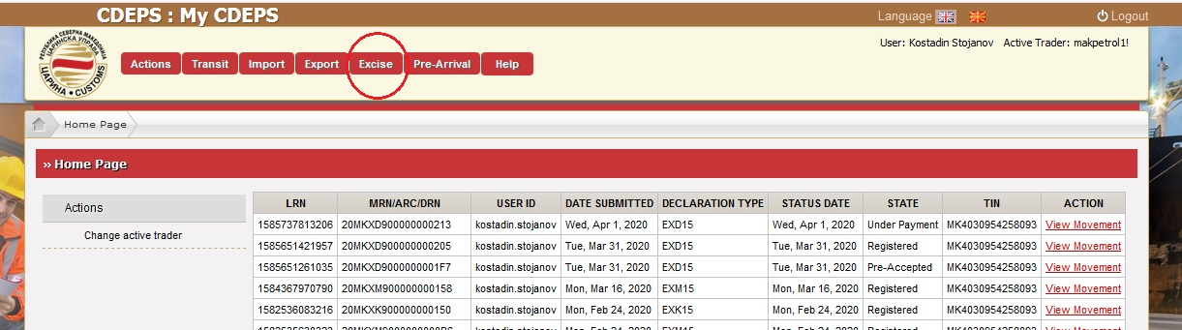
image 18

By selecting the tab Excise, different actions are revealed depending on the need, as shown on image 19:
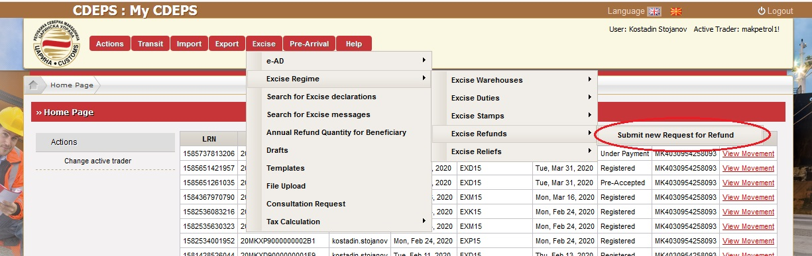Слика 19

In the sub-menu „Excise Procedure“ select „Excise duty refund“ and „Submit excise duty refund application“.

  - Submission of excise duty refund application

The "Excise Duty Refund Application" functionality describes the activities performed by the excise duty refund authorisation holder when submitting the application.

In the section "Basic details", the data for the application reference number and the date of submission are filled in by the system, while in the section "excise duty refund", i.e. "Refund Type" please select the refund application type from the drop-down menu, i.e. (1) Special subjects for official needs or (2) Special subject for private needs (Image 20).

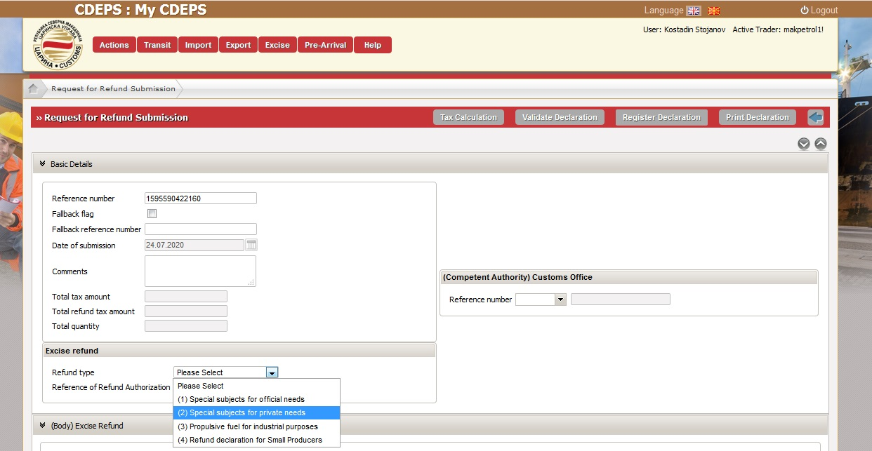
Image 20

After selecting the excise duty refund type, please complete the data from the invoices and accounts in the fields marked as "Excise Refund" ((Body) Exise Refund).

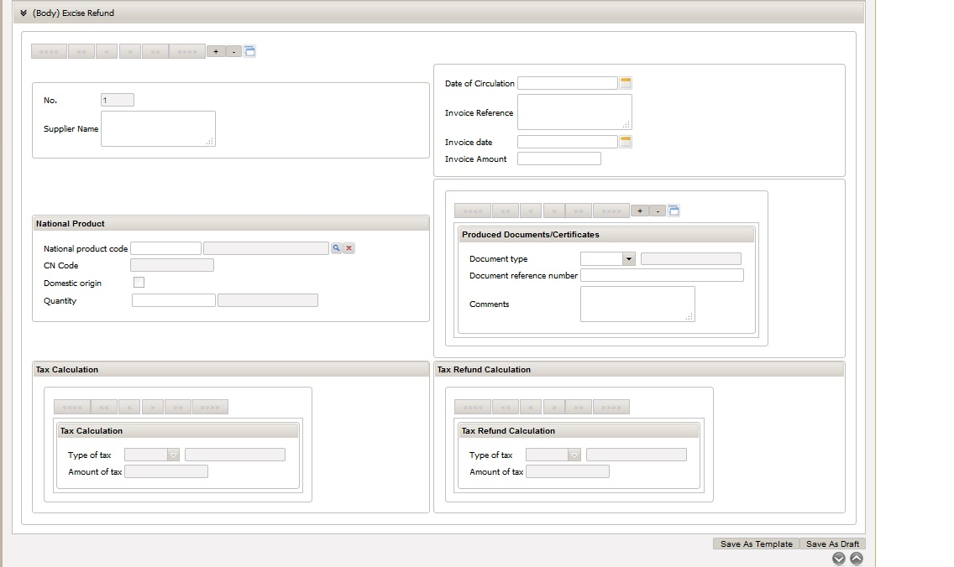
Image 21

The field "(Body) – Unique record reference number " shows the number of invoices entered in the system and is filled in automatically.
In the field "Supplier name" please enter the name of the supplier from where the excise goods were procured.
In the field "Date of circulation", select the date when the goods were purchased from the calendar, i.e. the date from the receipt with which the excise goods were procured.
In the field "Invoice reference" enter the number of the invoice with which the excise good was procured.
In the field "Invoice date" select the date of the previously entered invoice with which the excise goods were procured from the calendar.
In the field "Invoice amount" enter the fully paid amount of the previously entered invoice with which the excise goods were procured (Figure 22).

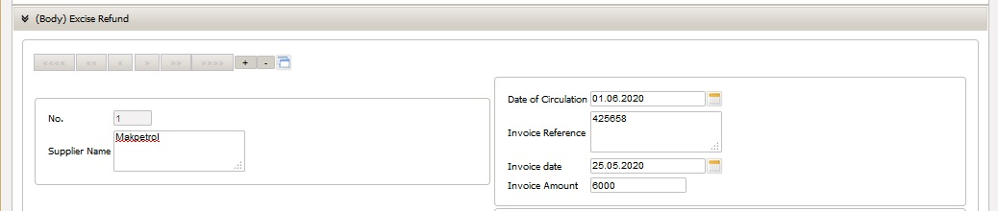
Image 22

In the part of application (Body) Excise duty refund“”National Product", "National Product Code" by clicking the search magnifying glass, a new window opens where excise goods can be searched for which the excise duty refund can be requested. In the search criteria, i.e. "National product category code" if the entered invoice refers to Alcohol and alcoholic beverages procured , select (A), if you wish to search Mineral oils, select (E) and for tobacco goods select (T), and then click "Search" (Image 23). The example of the following image, shows searching of mineral oils and to select any of the values ​​from the list, click on the product code shown in red.

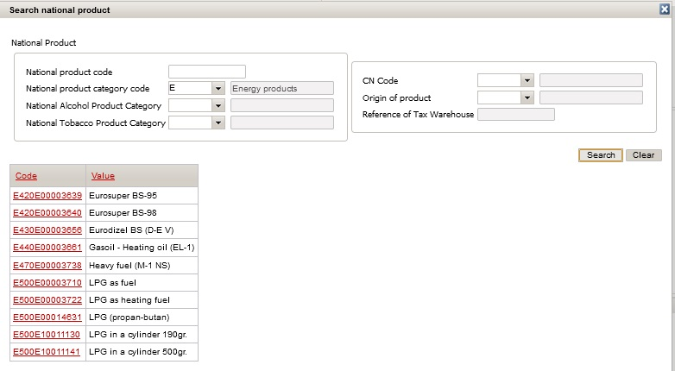
Image 23

After selecting the type of excise goods in the field, indicate the quantity (for mineral oils and alcohol in liters and for cigarettes in a unit of measure 1,000 pieces). In the attached documents section, select "FA03-Fiscal bill for procured excise goods" and state the fiscal receipt number, in case there is more than one purchase with one invoice. To enter the next invoice or part of the invoice, click on the sign "+" and to delete the inserted click on "-" (Image 24).

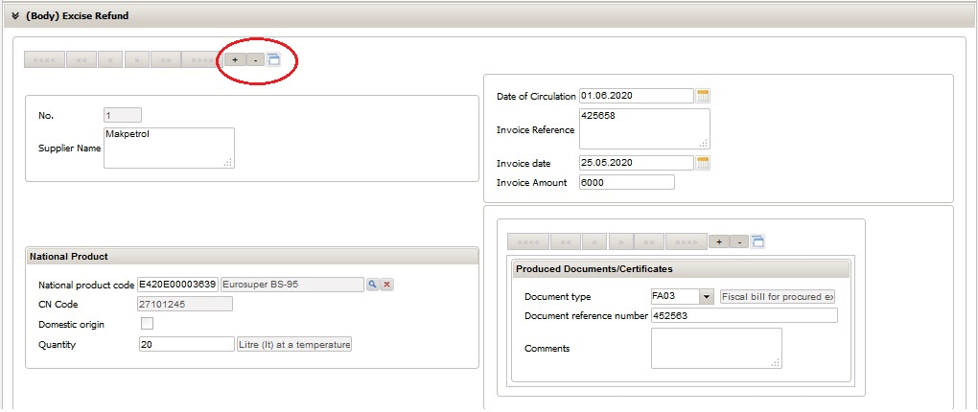
Image 24

If several receipts are entered from one invoice, click on "+", and rewrite the data about the supplier, the invoice number, the invoice date and the invoice amount, while new data for date of sale, national product code, the quantity and the number on the fiscal receipt are entered. To choose any of the tab numbers, you have an insight in each of the entered receipts and invoices in the application. (Image 25).

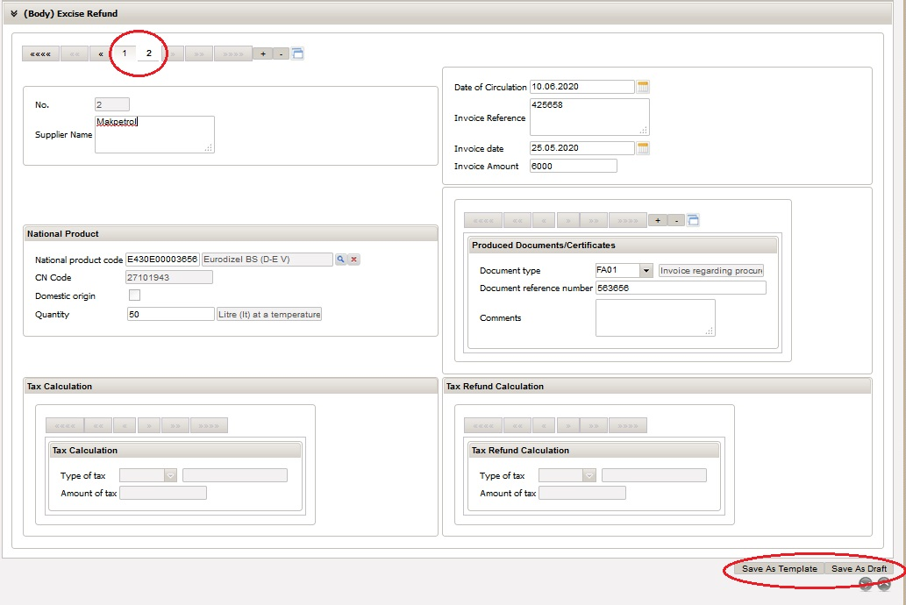
Image 25

During the filling in of the excise refund declaration, there is a possibility to save the declaration as a sample or as draft, by selecting one of these two options in the lower right corner of the declaration (Image 25).

The fields for calculating the excise duty amount provides an overview of the excise duty amount that will be refunded for each invoice or receipt by selecting the field "Excise duty calculation " at the top of the declaration.

Once the application is fully completed at the top of the declaration there is an option to calculate the duty, check the application, submit the application and to print it (Image 26).

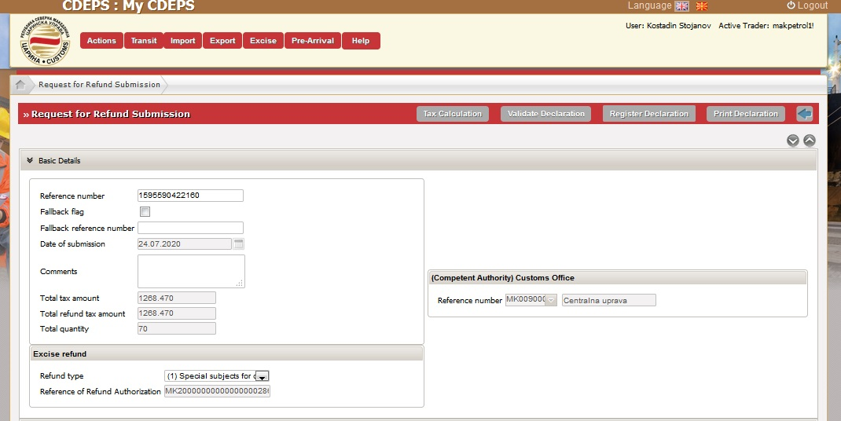
Image 26

By selecting the option “submit declaration”, the system will ask you to sign the declaration with a digital certificate.
Once the declaration has been successfully signed, the system shows the declaration with status "Submitted". All submitted declarations of the entity are then positioned on the home page of the logged user and the status of the declaration can be monitored in real time, whether it is accepted, rejected, additional data are requested and finally whether the excise duty has been refunded (Image 27).

